Chemical Plant

Revision 1.0

October 25, 2007

Addison Babcock

Introduction
It has come to my attention that there is an aspect of our operation that can be automated to increase productivity and reduce labor costs. In our chemical mixing room, employees blend together two chemicals of a fixed quantity for a fixed time. Instead of having an employee manually control and time the fill and mixing process, we can automate this using a PLC.

Problem Definition
In order to verify the accuracy of the various tools used, 3 separate modes (Waiting, Normal and Proving) will have to be implemented on the control software. During the initial Waiting mode, the operator will have a choice to enter Normal or Proving modes. The Normal state will be used to mix and dump chemicals as is done currently. The Proving state will be used to verify accuracy of the various meters. Refer to the documents “Chemical Plant Control” and “Proving the Turbine Meter” for further details of these states.

While in the Proving state, the operator can will fill the chemical tank to a predetermined level and then press a button to indicate to the PLC that the tank has been filled. The K-factor for the turbine meter will then be calculated and stored for use in the Normal state. After the calculation has been completed, the chemicals used for testing will be dumped back into the holding tank and the PLC will reenter Waiting mode.

During the Normal state, the mixing tank will be filled with a predetermined level of chemical A, mixed for a set time, and then dumped into a holding tank. After all of chemical A has been dumped, the mixing tank will be filled with chemical B which will also be mixed for a set period before being dumped into a holding tank. Both chemicals will then be pumped back into the mixing tank and mixed for a certain period before being dumped into a pipe leading to the packaging department. Once all the product has been sent to packaging, the system will begin another batch of product.

At any time during Normal operation, the operator may press a stop button to interrupt the process. Then the operator may press a dump button to empty the mixing tank for cleaning and maintenance. After the tank is empty the software will return to the waiting state and the operator may select Proving or Normal operation.

Black Box Diagram
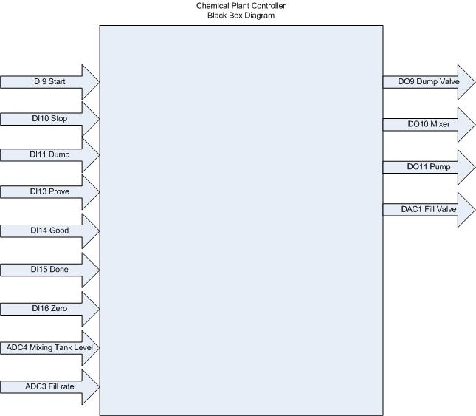
Figure 1: This diagram shows the inputs and outputs as well as the pin mappings that will be used in this project. It is included to demonstrate to the programmer which pins are available to be used on the PLC.

State Diagram

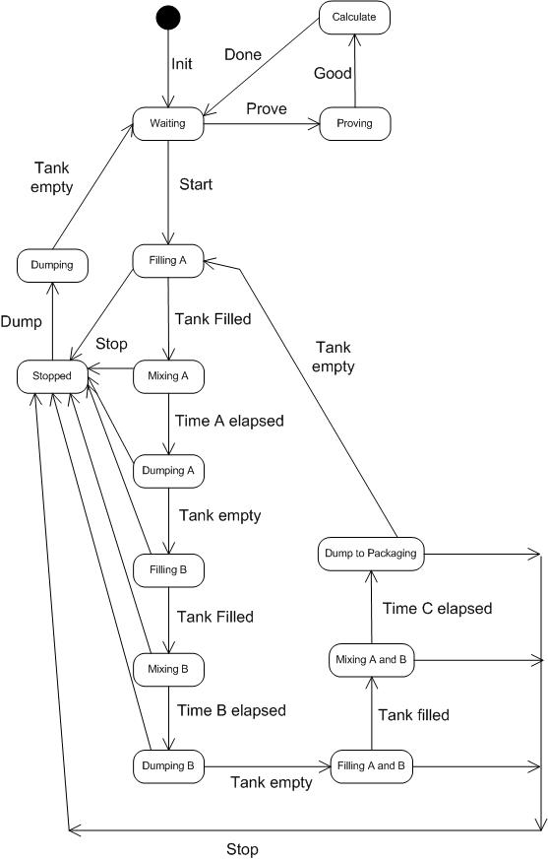
Figure 2: This state diagram is included to give a visual description of the various processes which will be controlled by the PLC.

Equations
Waiting = (Tank Empty * Dumping) + (Calculate * Done) + 1st.Scan
Proving = Waiting * Prove
Calculate = Proving * Good
Filling A = Waiting * Start + Dump
Mixing A = Filling A * Tank Filled
Dumping A = Mixing A * Time A Elapsed
Filling B = Dumping A * Tank Empty
Mixing B = Filling B * Tank Filled
Dumping B = Mixing B * Time B Elapsed
Filling A and B = Dumping B * Tank Empty
Maxing A and B = Filling A and B * Tank Filled
Dump To Packaging = Maxing A and B * Time C Elapsed
Stopped = (Dump To Packaging + Maxing A and B + Filling A and B + Dumping B + Mixing B + Filling B + Dumping A + Mixing A + Filling A) * Stop
Dumping = Stopped * Dump

Conclusion
For this project I will be using TriLogi software to program a T100MD+ PLC in ladder logic. The PLC will be connected to the chemical plants internal control system by a 25 pin parallel cable. The PLC will also require a power cable and serial connection to a personal computer for programming.

